Brief instruction for using GLASS products
Welcome to the world of GLASS products – a valuable source of data for various applications. In this guide, we will walk you through the process of using GLASS products in three commonly used software platforms – HDF Explorer, ENVI and ArcGIS Pro. Let us delve into the details of utilizing GLASS products in these platforms.

HDF Explorer
Through HDF Explorer, you can observe information such as valid value, scale factor, fill_value, units and so on.
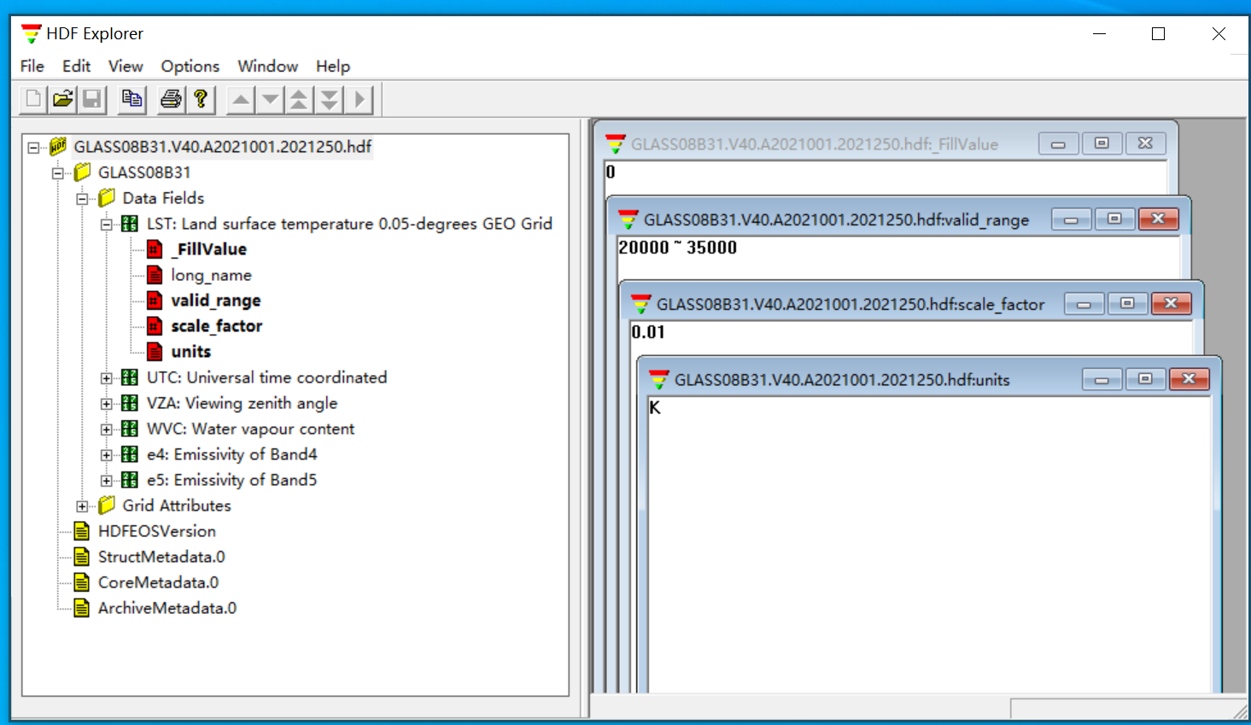

ENVI
Introduction:
This guide provides step-by-step instructions on how to use GLASS products through the ENVI software (version 5.3). By following these instructions, users will be able to install the necessary plugin, open GLASS product files, and display projection information.

1. Plugin Installation:
To begin, follow the steps below to install the required plugin:
1) Locate the plugin file and place it in the "save_add" directory of the ENVI installation program. For example, the directory path may be: C:\Program Files\Exelis\ENVI53\classic\save_add.
2) After placing the plugin in the correct directory, open the ENVI software again.
3) Verify that the plugin has been successfully installed by checking if the "Open Glass File" option appears in the File drop-down menu.

2. Opening GLASS Product Files:
Follow these steps to open GLASS product files in ENVI:
1) In the ENVI software, click on the File drop-down menu and select the "Open GLASS File" option from the menu. Choose the GLASS product file you wish to open by browsing through your files
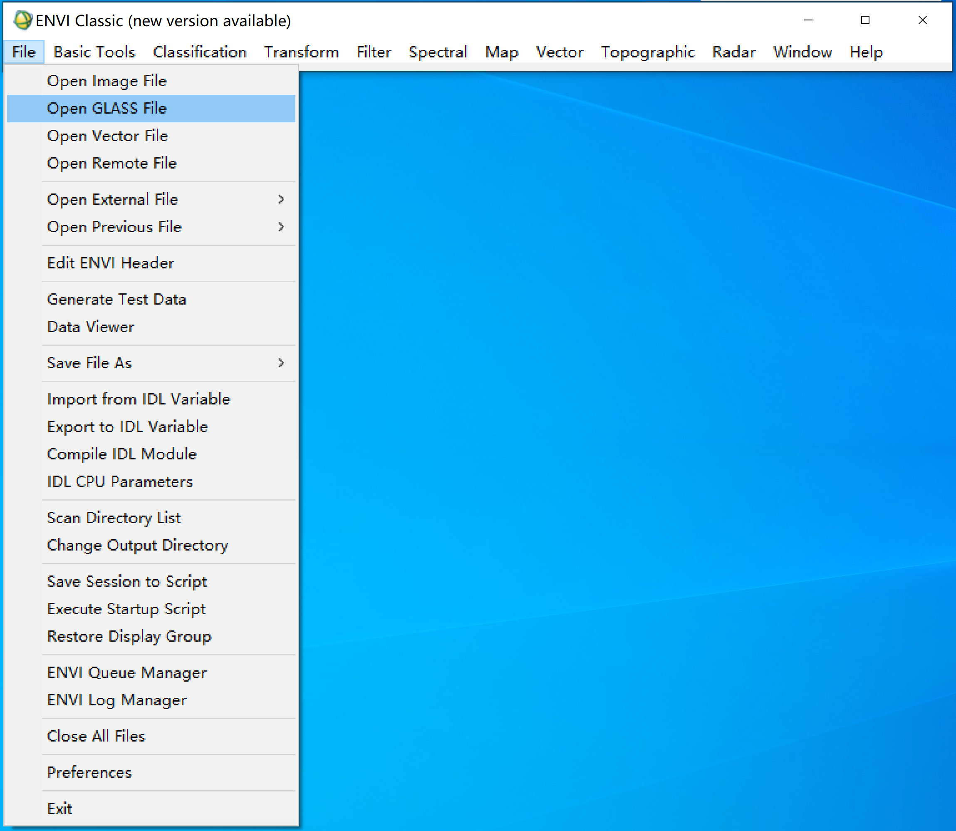
2) Choose to output to file or memory as needed;
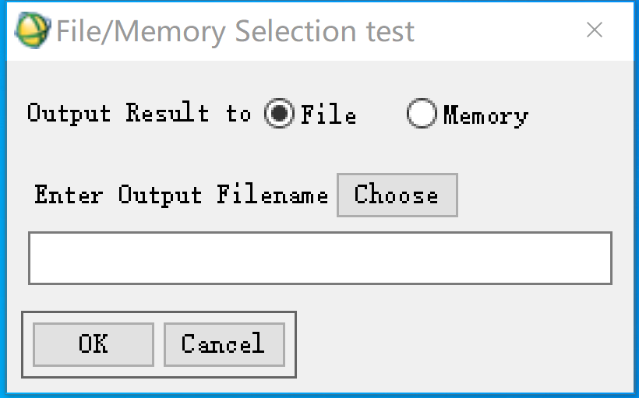
3) Open the GLASS product file and display the projection information.
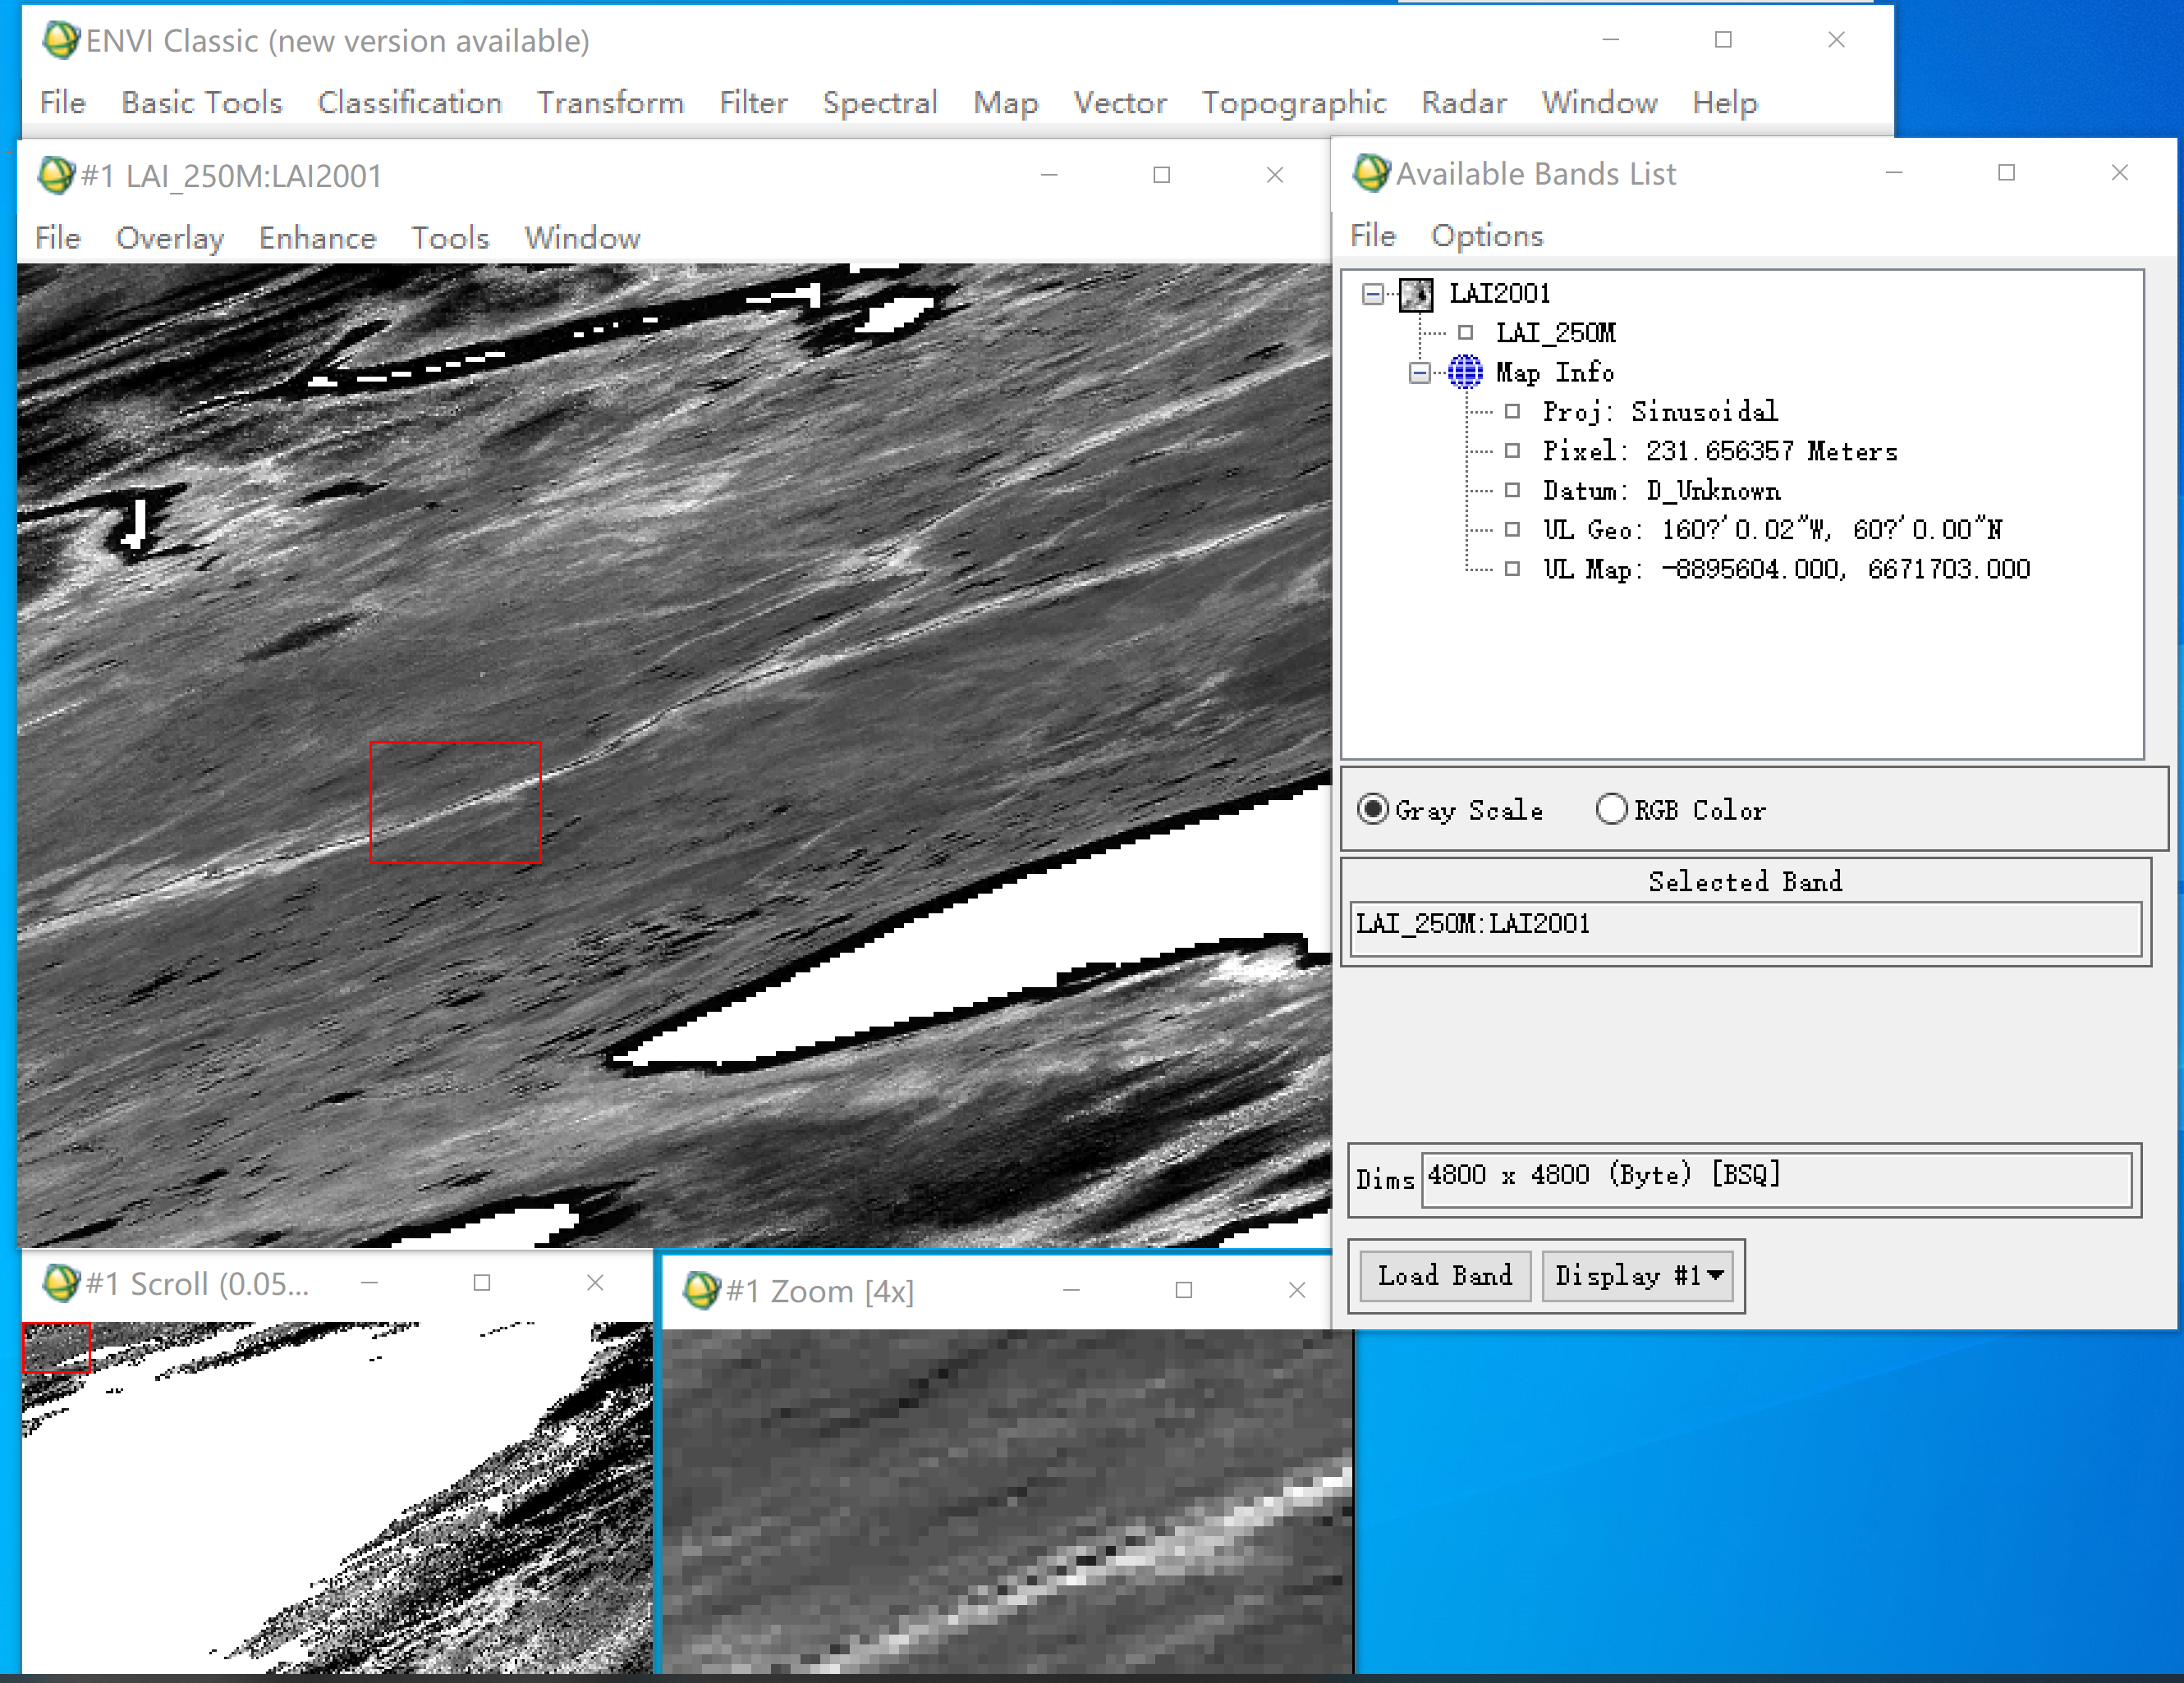
4) Enter longitude and latitude.
Right-click on the image and select "Pixel Locator". In the pop-up "Pixel Locator", click the icon , select your preferred longitude and latitude input method, and enter the longitude and latitude.
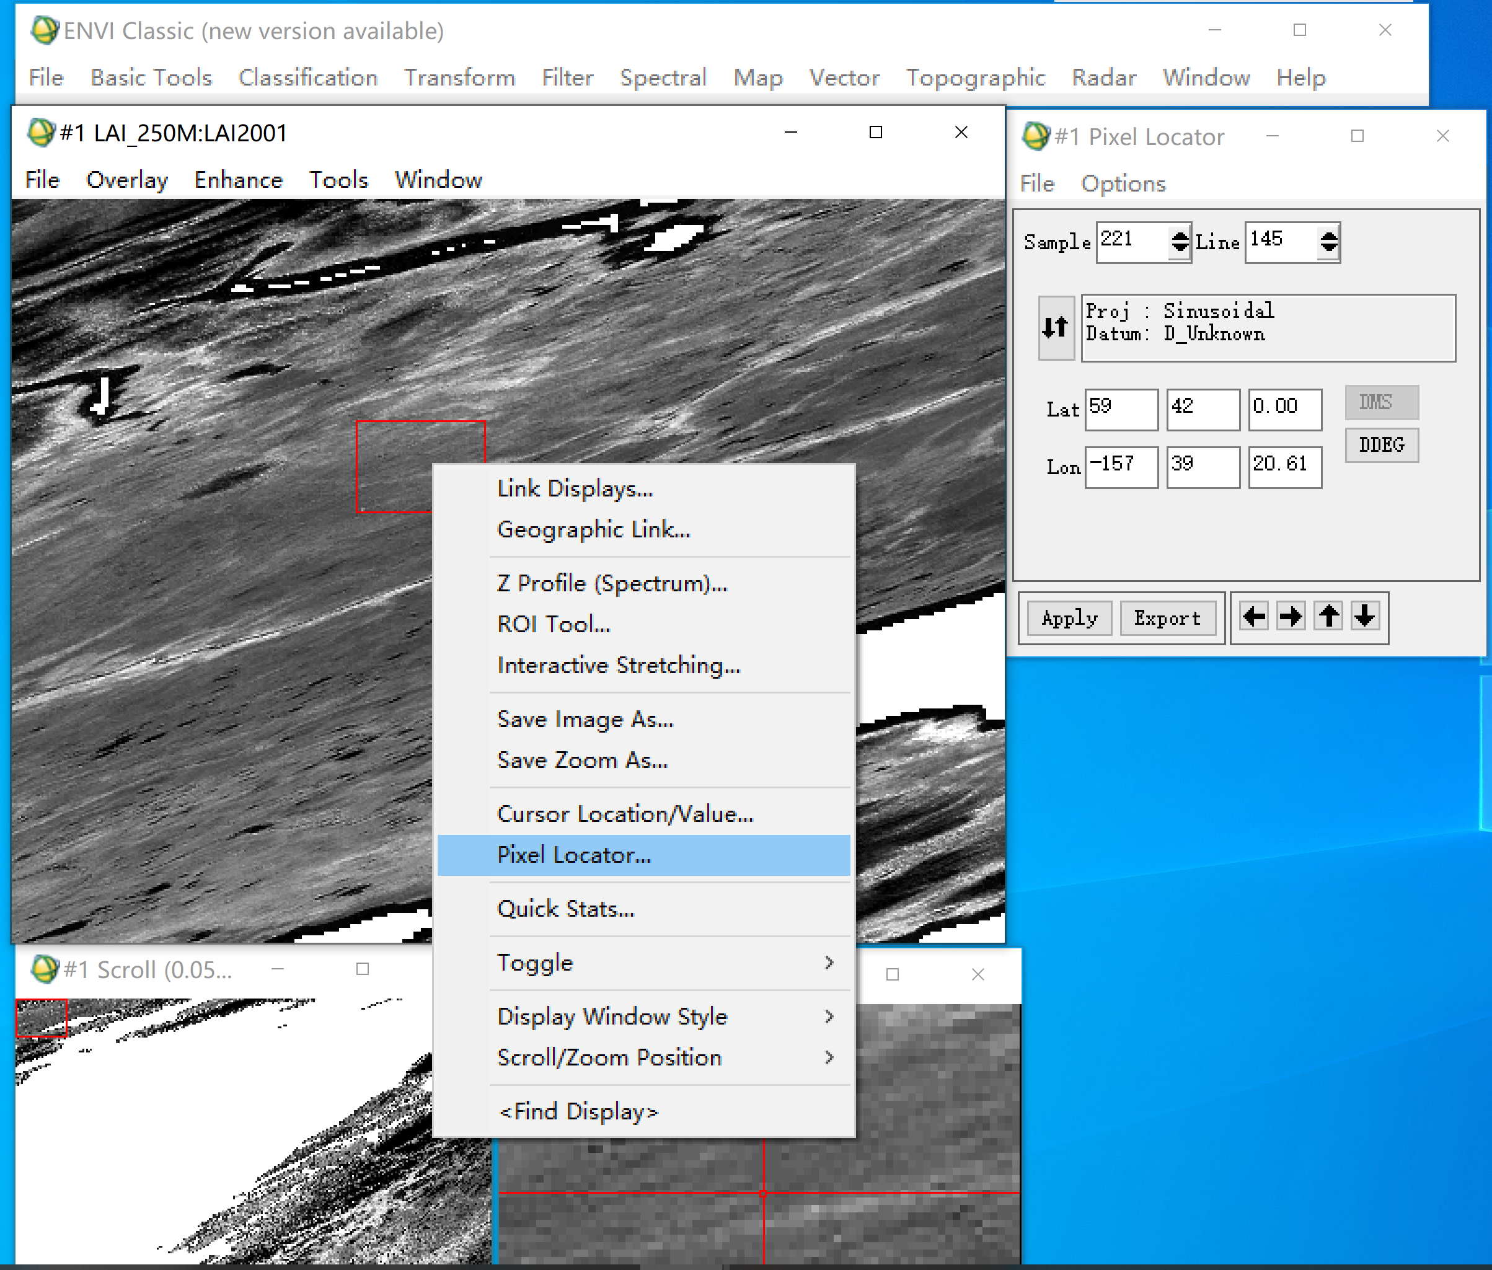
5) View the value of this location.
Left-click this position twice, and “Cursor Location/Value” will pop up to see the value of this position.
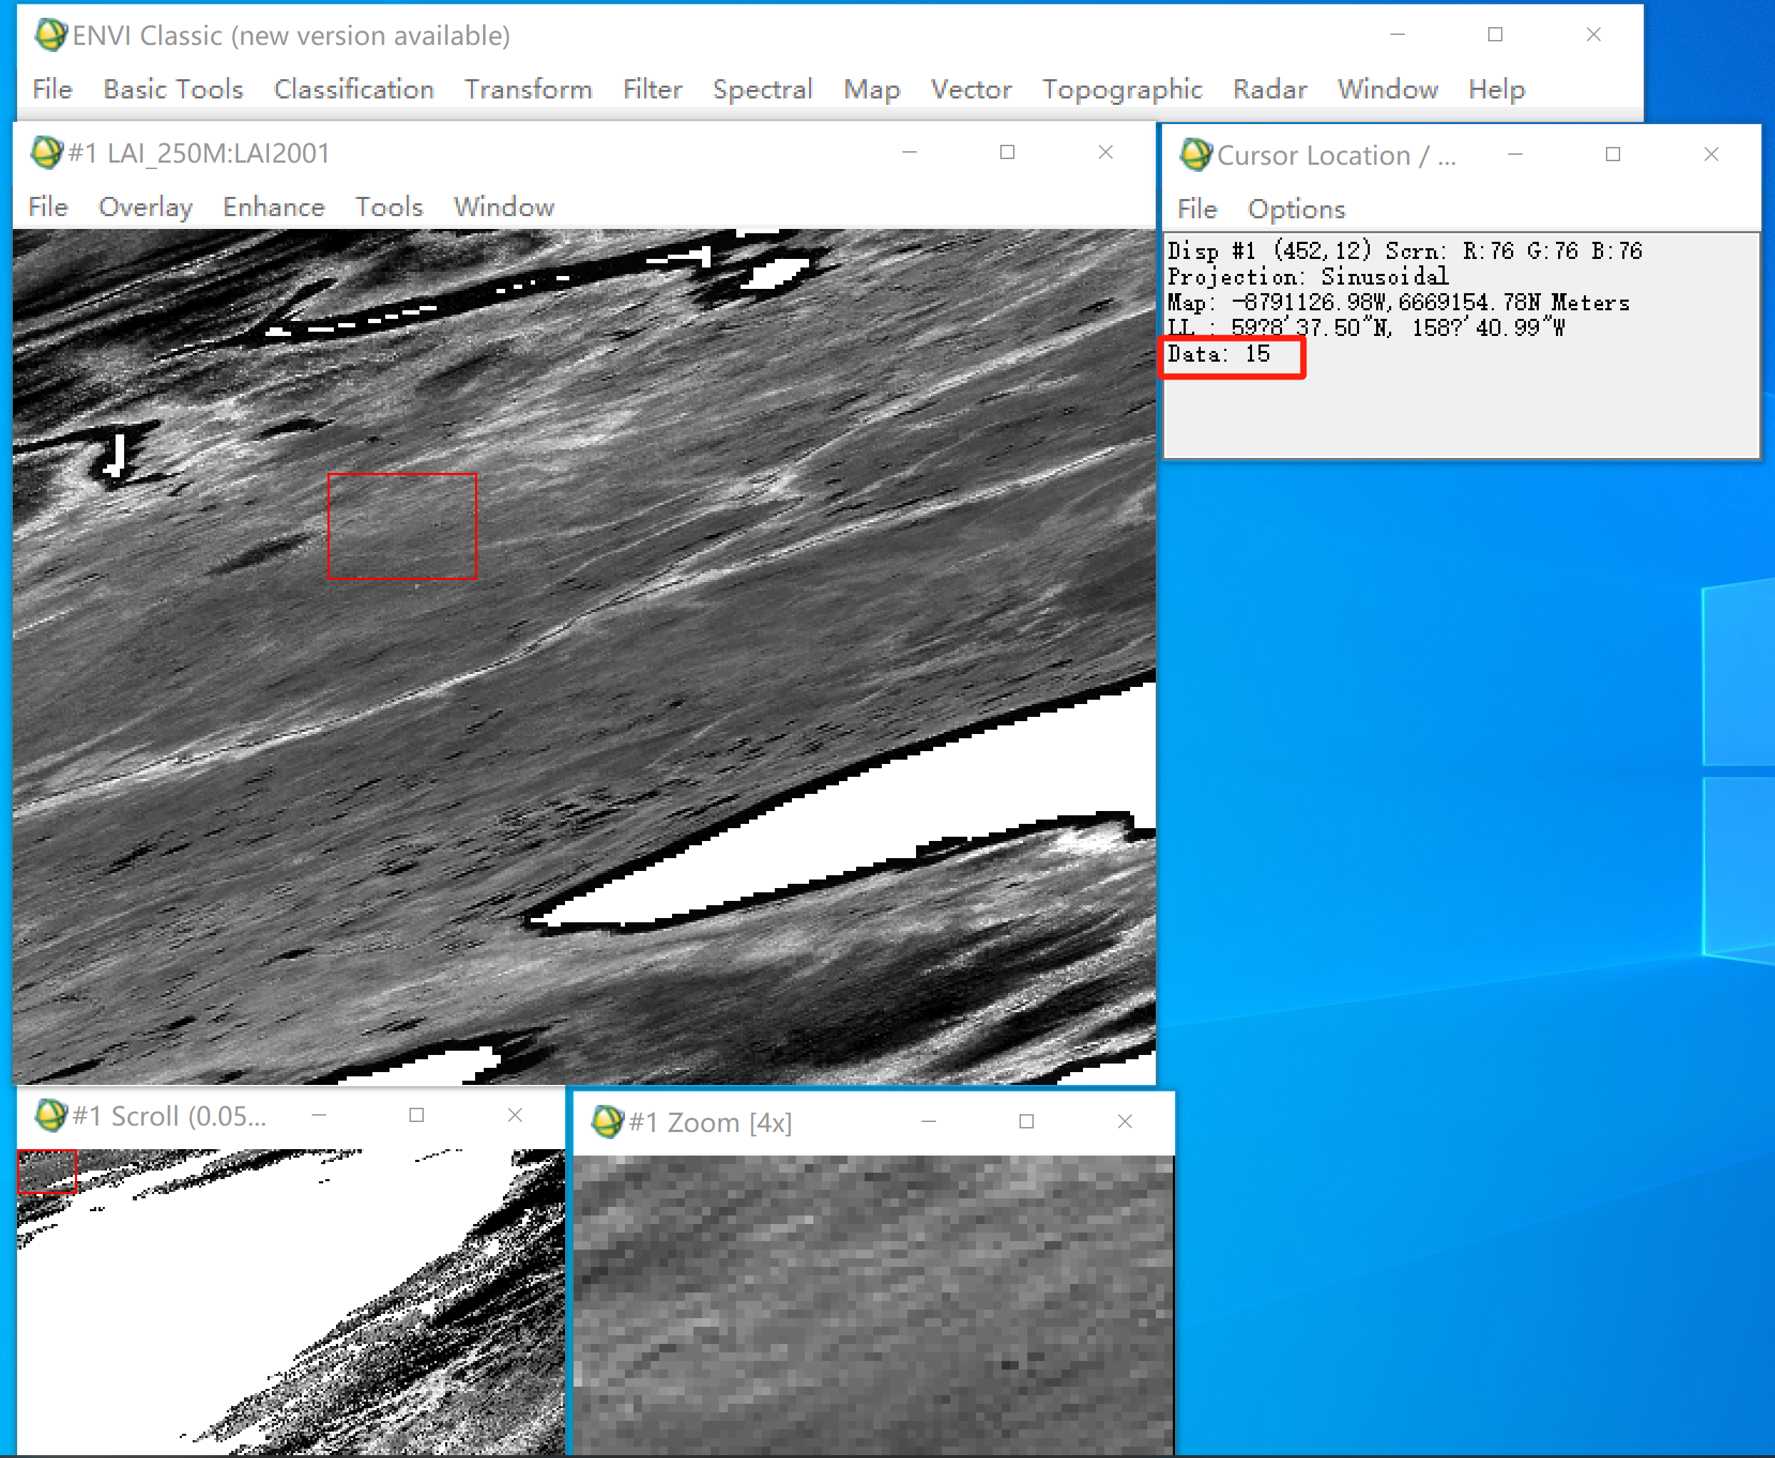

ArcGIS Pro
1. GLASS products can be directly utilized in ArcGIS Pro for analysis and mapping purposes.
2. Location information
Prior to using GLASS products, it is important to note that ArcGIS Pro only recognizes location information in decimal degrees format. If your existing data is already in decimal format (e.g. 116.1234, 23.1234), simply import it directly into ArcGIS. However, if your data is in degrees, minutes, and seconds format, it must be converted to decimal format before proceeding. Save location information in EXCEL, as an .xls file.
Example:
3. Loading location information
Load the table into ArcGIS and select "Display XY Data".
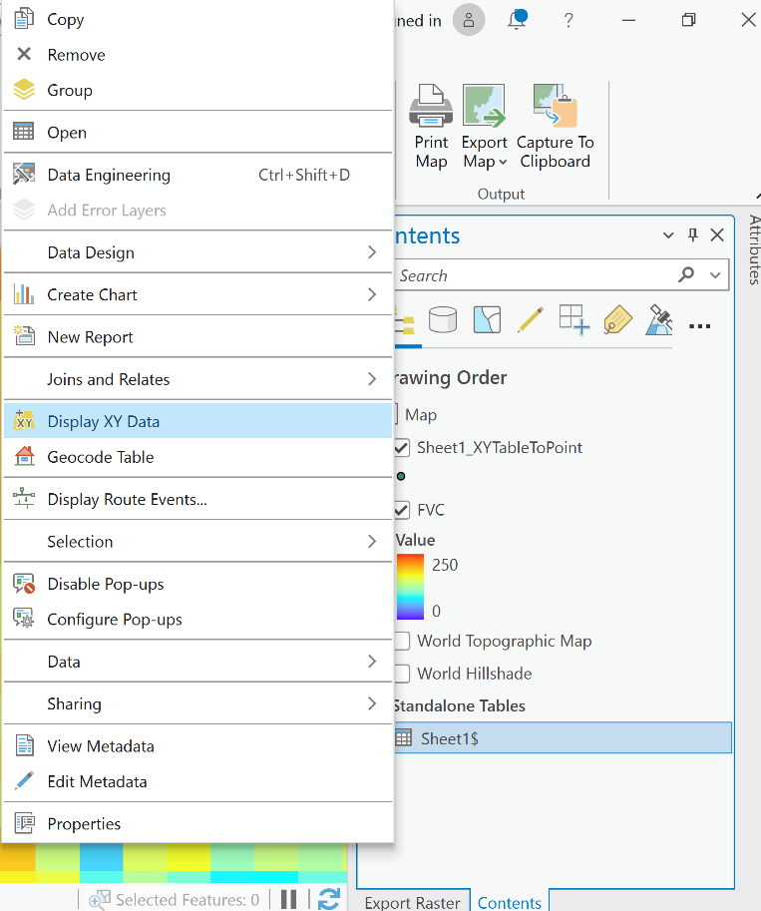
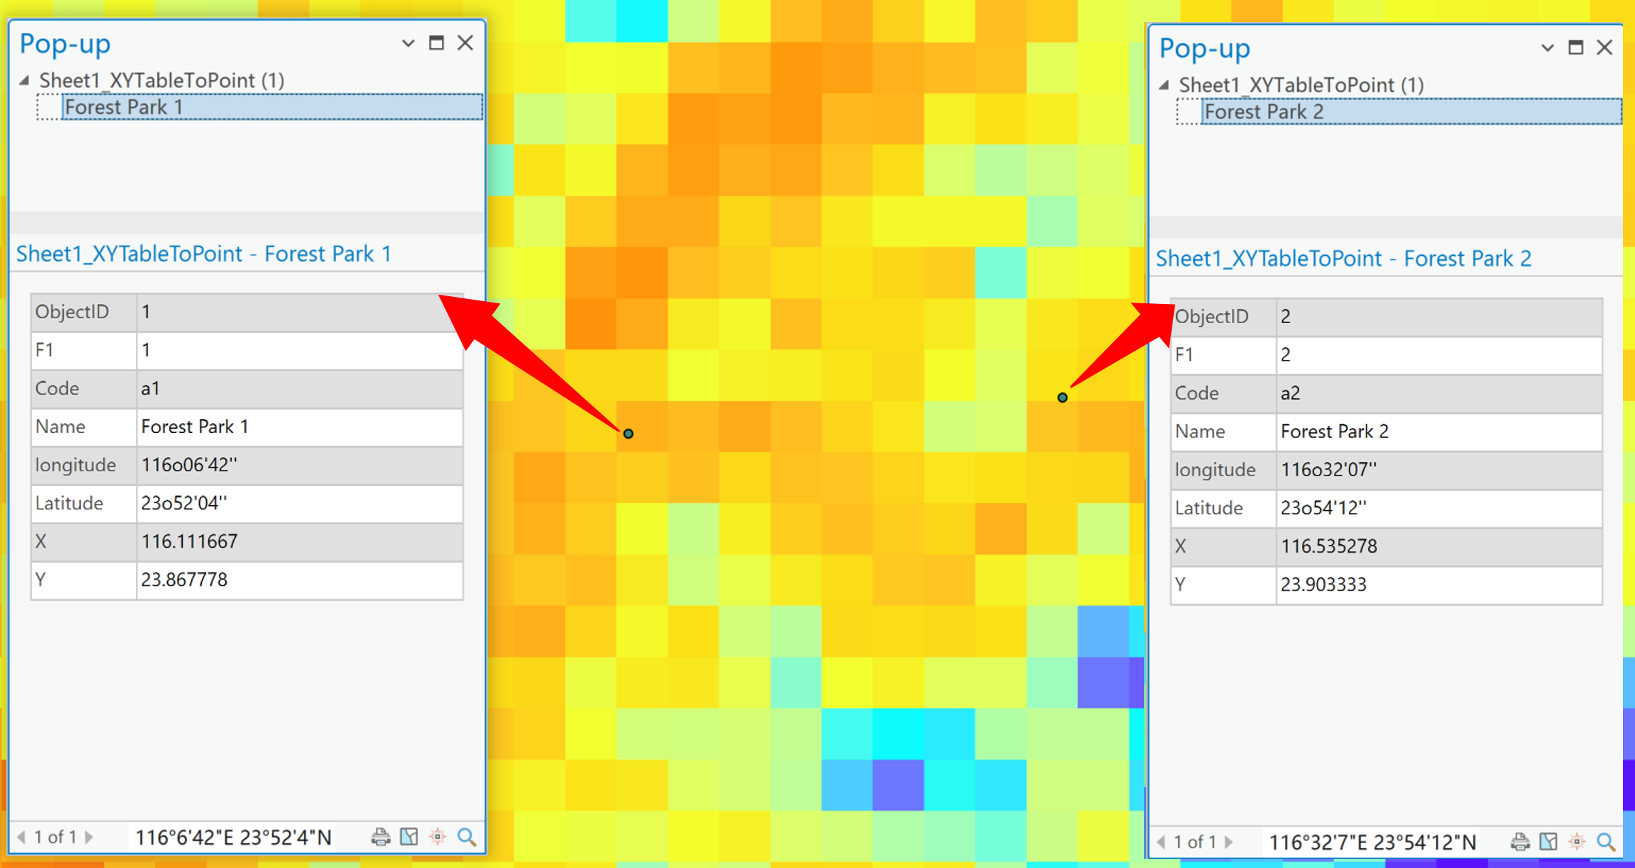
4. Click on the specific pixel to view its corresponding value.
